Exterior Rendering Checklist
Company
Contact | Email
Contact | Tel
Contact | Address
Contact | Contact Person
Customer Special Requirement：

Files Customer needs to provide |  |  | Details | Comments
I. Plans |  |  | CAD file name
1. Floor plans
2. Roof Plan
3. Elevations from four sides
4. Sectional drawing
II. Surroundings
1. Site Plan/Aircraft View/Satellite Photo
2. Street Surroundings photos
III. Color & Material
1. Material sample picture
2. Color Standard code RGB
3. Zoning of color and material in plans
IV. Viewing Angle
- Choose point of plane view    - Please circle the point  - Please indicate separately for special point of view |  |  | 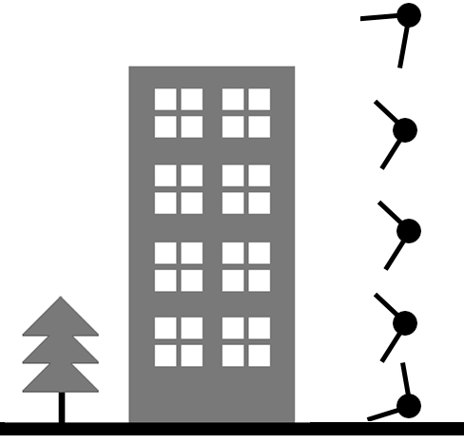  - Choose point of vertical view

